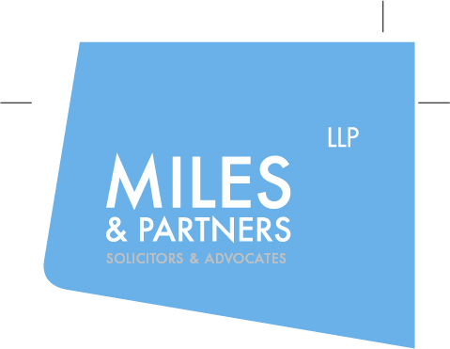

Miles & Partners are looking for Legal Assistants

We are a highly regarded firm of solicitors ranked in Legal 500 and Chambers. We are based in London E1 near Liverpool Street and The Cloud. Our clients are all over the World. Check out our website to see what they say about us https://milesandpartners.com/about/testimonials/. We are looking for a bright law graduates with a professional outlook to join our team of Legal Assistants providing paralegal support to a senior member of our public law Family Team. The roles start in July 2021 and will suit BPTC/ LPC graduates or similar looking for good quality professional experience while preparing to apply for Training Contracts or Pupillages. Experience of working in a busy legal environment with Legal Aid and CCMS will be an advantage but is not essential. We are currently also working from home (whilst looking forward to a return to the office in the summer!) so you need to be self-motivated, comfortable with working remotely and possess a willingness and ability to work independently whilst maintaining professional standards. The successful applicant will of course also have a positive outlook, good communication skills, numeracy and IT skills, a willingness to learn and accept responsibility, enthusiasm, commitment and the ability to work well in a team. The post on offer has a wide range of duties ranging from some clerical work to liaising with the Legal Aid Agency, the courts, experts, counsel etc., attending interviews with experts to take notes, assisting in arrangements for conferences, preparation of court bundles and accompanying documentation, preparation of documents for Counsel and occasionally attending Court with Counsel. With appropriate experience and training we would expect you to progress to preparing statements and applications, attending clients and taking instructions, and legal research. The successful candidate will be offered a minimum engagement of twelve months. Salary £21,500 pa. Please send C.V. and a covering letter to Phil Walsh at pw@milesandpartners.com by 8th July 2021.

