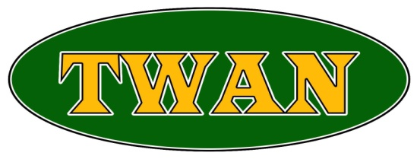

TAMIL WELFARE ASSOCIATION (NEWHAM) UK

Website :www.twan.org.uk email:twan@twan.org.uk Tel: 0208 478 0577
Job Title: Family Welfare Solicitor
To note: This role is available on a part time basis.
Job Description:
We require a solicitor in the areas of family welfare and debt advice to join our legal advice clinic. The successful candidate will take on cases relating to a wide variety of issues relating to the financial resilience of families, be comfortable with the welfare system including appeals, and relish the challenges of working towards holistic solutions for the client.

This role is based in our office in Newham.

Tasks will include:
- Preparation of applications including taking instructions and making online applications – this requires significant levels of client contact;
- Providing telephone advice and able to undertake outreach work when required;
- Remaining aware of all relevant rules, policies and best practice affecting all aspects of welfare and debt advice with a working knowledge of how to support with issues relating to family, employment, housing;
- Proactive management of casework, advice to clients and general service delivery, ensuring the highest standards are consistently met; and
- Build up a network of partners, including statutory authorities such as local authorities.
Requirements
Applicants must:
- Be qualified as a solicitor;
- Be willing to be based in the office for the duration of their employment;
- Possess excellent communication skills, both written and oral;
- Be comfortable with using Microsoft Office and the online system for welfare and debt advice work;
- Demonstrate high levels of analysis; and
- Have experience of client contact and care and previous experience in this field of work.
Desirable:
- Candidates with experience or knowledge of advocacy are preferred.
To apply, please send your CV and a covering letter to: Twan@twan.org.uk
Salary: £30,000 per annum on pro rata basis.
Office location: 602 Romford Road, Manor Park E12 5AF

About TWAN: The Tamil Welfare Association Newham UK ("TWAN") is a community based legal advice clinic, providing a range of services aimed at the growth and empowerment of Tamil speaking individuals in the United Kingdom. It holds the Legal Aid Agency’s Specialist Quality Mark.

TWAN has successfully completed 40 years of service to the Tamil community in the UK and continues to grow. Formed initially to assist asylum seekers and victims of war and torture, we continue serve this group as well as specialising in other immigration matters. We also provide advice across a range of social welfare areas. In recognition of this, we have been working in partnership with the Greater London Authority and the London Legal Support Trust to provide additional support to the community through the cost of the living crisis. This role is funded by that partnership.

