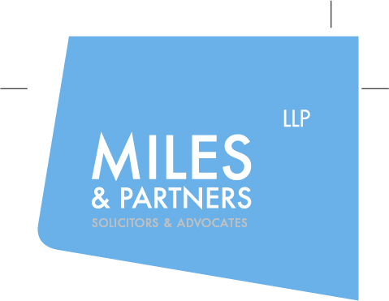

Miles & Partners are looking for Legal Assistants

We are a highly regarded firm of solicitors ranked in Legal 500 and Chambers and have been listed in The Times Top 200 Law Firms for 3 years running. We are based in London E1 near Liverpool Street and The Cloud. Our clients are all over the World. Check out our website to see what they say about us https://milesandpartners.com/about/testimonials/. We are seeking a bright law graduate with a professional outlook to join our team as a Legal Assistant providing paralegal support to our busy specialist award winning lawyers. The role starts in March 2022 and will suit BPTC/ LPC graduates or similar looking for good quality professional experience while preparing to apply for Training Contracts or Pupillages.

Experience of working in a busy legal environment with Legal Aid and CCMS will be an advantage but is not essential. We are committed to agile working so you need to be self-motivated and possess a willingness and ability to work independently whilst maintaining professional standards. The successful applicants will of course also have a positive outlook, good communication skills, numeracy and IT skills, a willingness to learn and accept responsibility, enthusiasm, commitment, and the ability to work well in a team.

The posts on offer have a wide range of duties ranging from some clerical work to liaising with the Legal Aid Agency, the courts, experts, counsel etc., attending interviews with experts to take notes, assisting in arrangements for conferences, preparation of court bundles and accompanying documentation, preparation of documents for Counsel and occasionally attending Court with Counsel. With appropriate experience and training we would expect you to progress to preparing statements and applications, attending clients and taking instructions, and legal research. The successful candidates will be offered a minimum engagement of twelve months. Salary £23,000 pa. Please send C.V. and a covering letter to Phil Walsh at pw@milesandpartners.com by the 23rd March 2022.

