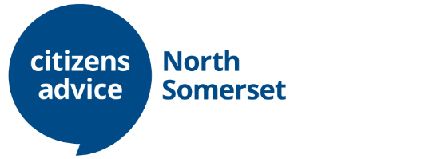
JOB OPPORTUNITIES

Advice Session Supervisor

We are looking to recruit a highly motivated Advice Session Supervisor to join our Generalist Advice team. You will supervise paid and volunteer advisers delivering advice remotely and in various advice locations across North Somerset. You will be supervising multi-channel advice (telephone, digital and face-to-face) to North Somerset residents on a wide range of issues such as benefits, debt, housing, employment, family and immigration. You may also be required to deliver advice when necessary. This role can be delivered remotely within the UK.

The successful candidate(s) will have generalist advice and/or supervisor experience in a Citizens Advice or equivalent setting and will need to have good communication skills and a commitment to delivering a high quality service. Supervisor training will be available for the right candidates.

Locations: Remote working / locations across North Somerset
Hours: Up to 37.5 hours per week with an opportunity for job share
Contract: Permanent
Salary: £22,100 to £25,575 depending upon experience

Citizens Advice North Somerset (CANS) is an established and well regarded local independent charity who provide free, impartial and confidential advice. We undertake research & campaign work to influence policy makers and to effect change. We work in partnership with the Local Authority, The Legal Aid Agency, Macmillan Cancer Support, The Money Advice Service, Wessex Water and many more local and national partners to deliver our advice services to over 7,500 clients living and working in North Somerset.

The application pack is available on our website: www.nscab.org.uk. For an informal conversation about the role please email katherine.hutton@nscab.org.uk or call 01934 836204.

Closing date: 15th August 2021
Interviews will take place during the week of the 23rd August 2021
Completed applications to be emailed to HR@nscab.org.uk

